 Pegasys
[Course Code]

- Pegasys allows users to save a Course Code into the system. This will allow other users to use this course code in the future.

Figure 1
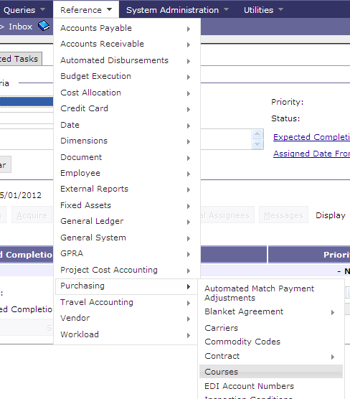

Figure 1

- Go to Reference-Purchasing-Courses

Figure 2
Figure 2

- Click New
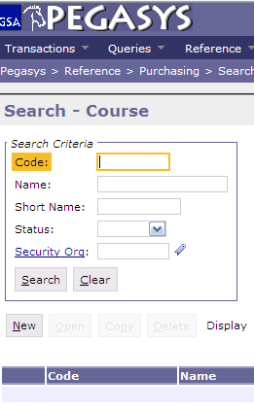

Figure 3

- Enter Course Code in the Code field
- Enter Course Name in Name field
- Click Save

Figure 3
